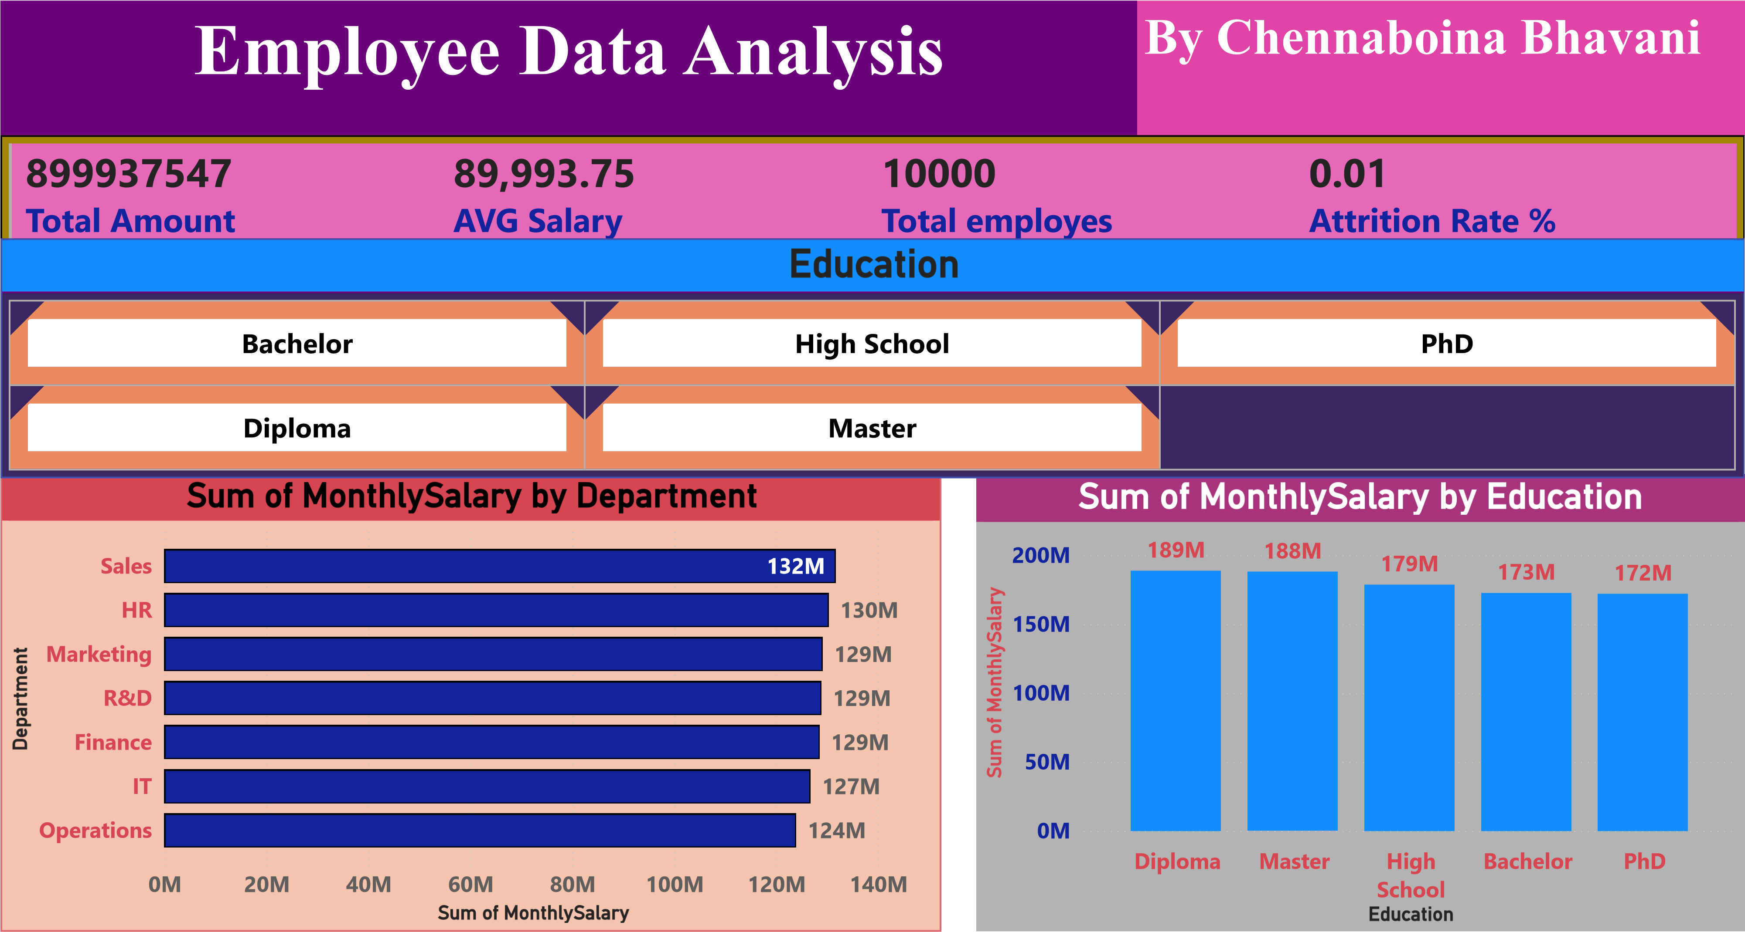
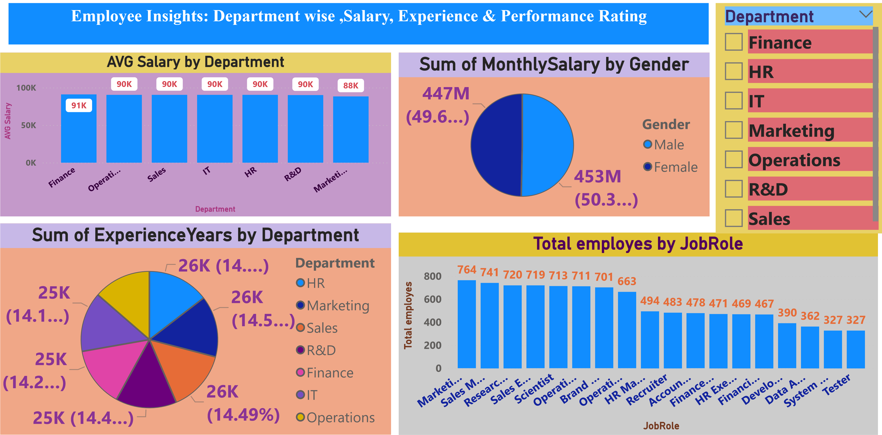
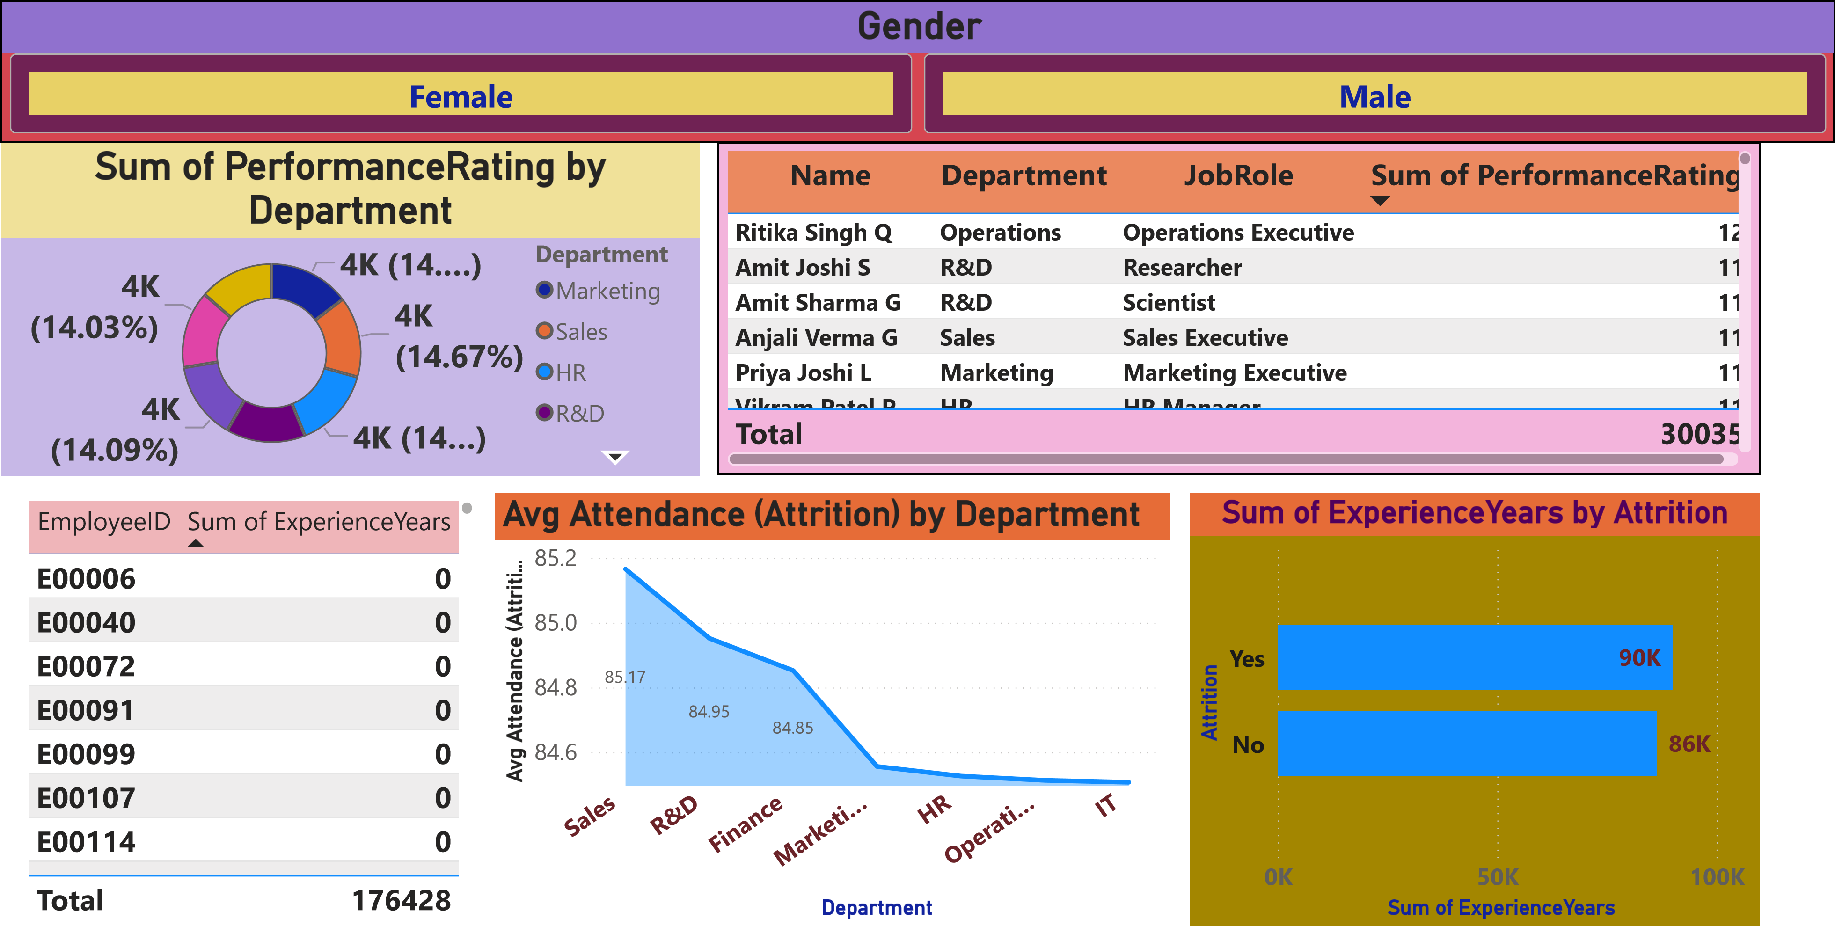
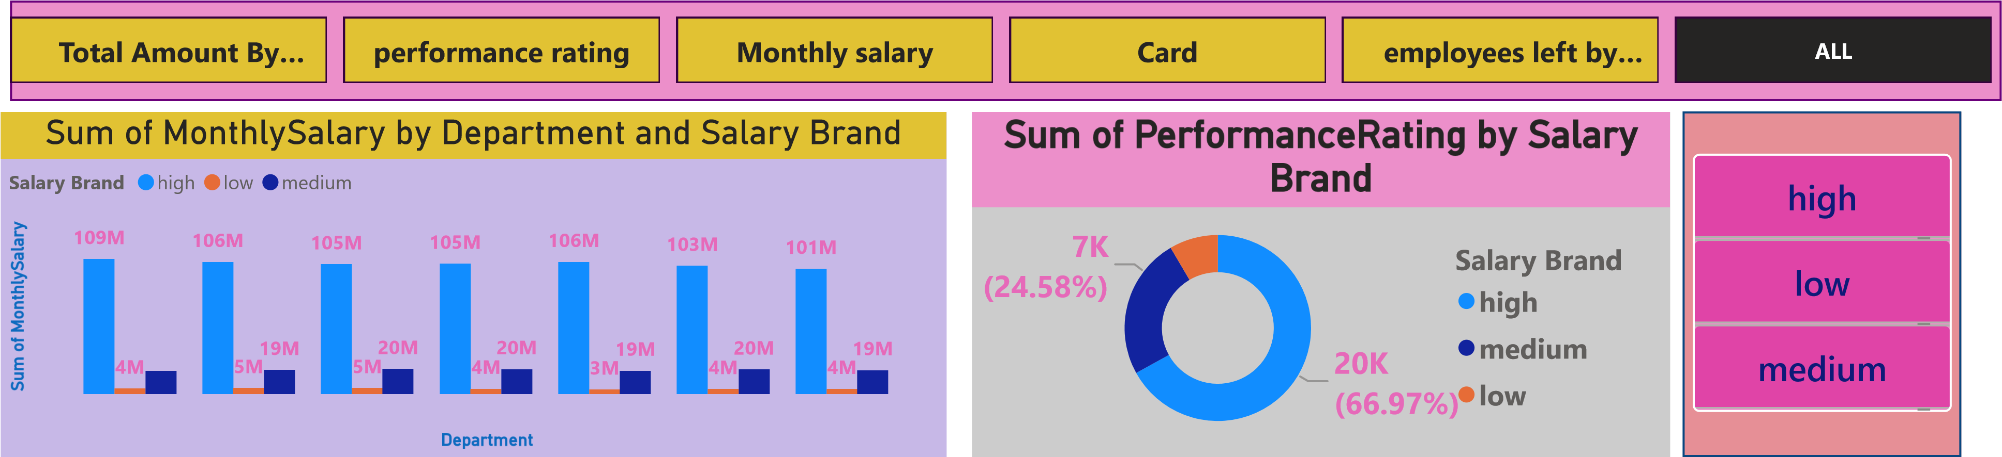Sales HR Marketing R&D Finance IT Operations
Total Amount by Department |  |  |  | Sum of Employees Left by Department
124M (13.78%)  1  127M (14.1%)  129M (14.29%) | 32M (14.64%) Department  130M (14.49%)^{Sales} HR  Marketing 129M (14.36%) |  | S  u  m  o  f  E  m  p  l  …  Finance  708 | Department  HR  IT  Mark  eti…  Operati…  R&D  Sales  721  747  704  742  722  713  Sum of Employees Left
Power BI Desktop
Sum of MonthlySalary by Department and Education |  | High Performers by Education
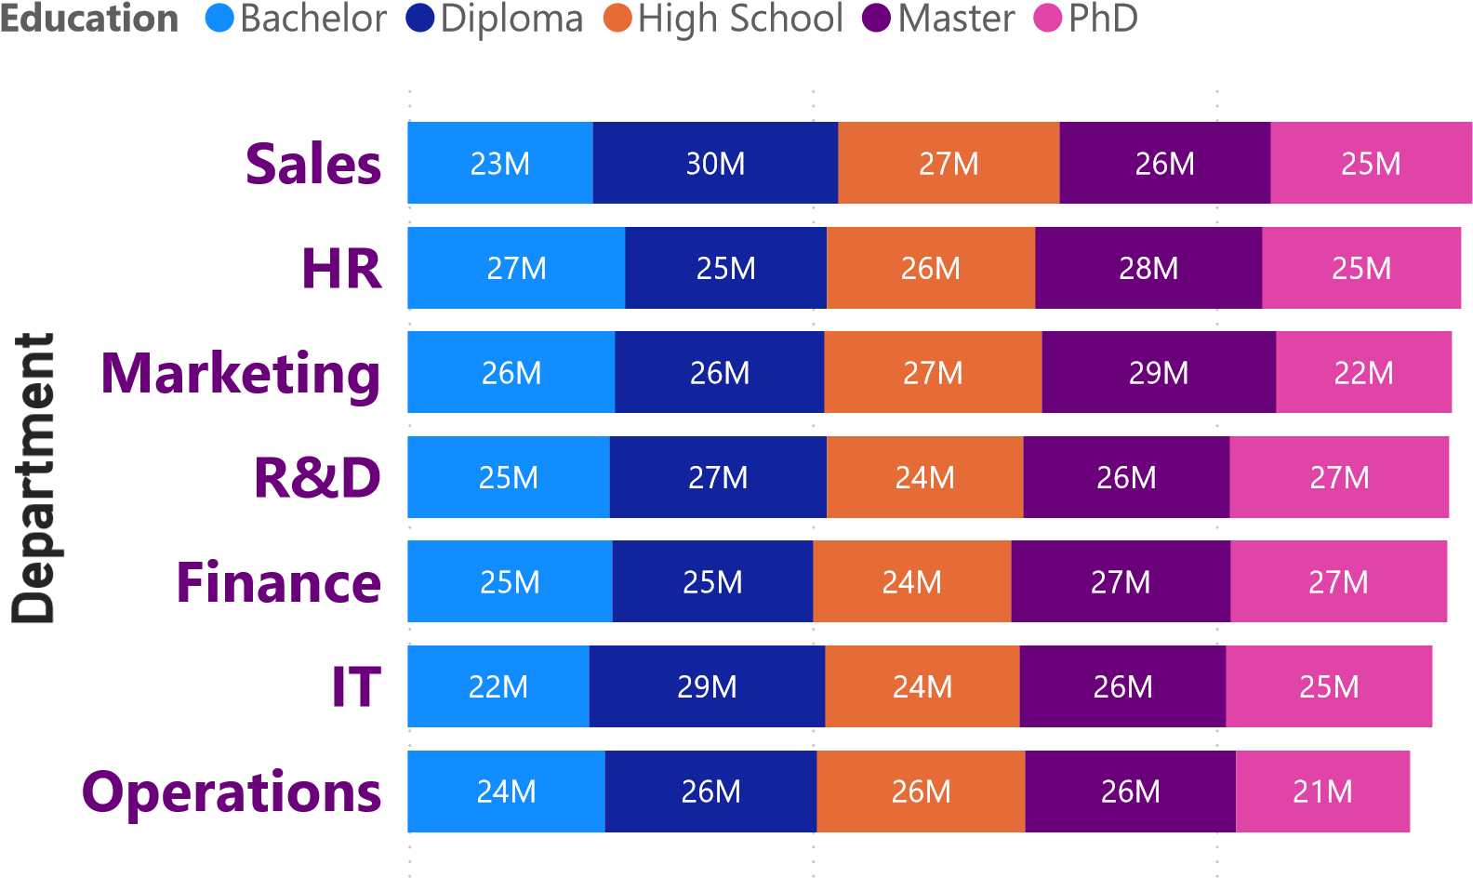
(19.99%)
(19.…)
(20.…)
(18.97%)
804
802
812
841
763
Education
Bachelor
Diploma
High School
Master
PhD
0M 50M 100M

Sum of MonthlySalary (20.19%)

